

Date:
Breakfast |  | Water  Vitamins  
Lunch
Dinner
Snacks
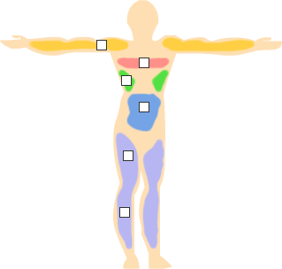
 | Exercise Details
 | Weight
 |  | Morning
 |  | Evening
 | Notes

The Fitness Folio is a multi-use chart that you can use to track your daily nutrition, water/vitamin intake, exercise, and weight.

