
Date | Arm  (A) | Chest  (B) | Waist  (C) | Hip  (D) | Thigh  (E)
 |  |  |  |  | 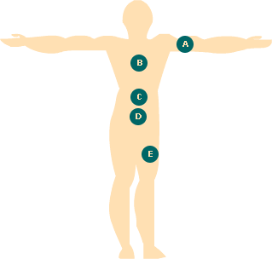

This Body Measurements chart is useful in tracking body fat changes. Using measuring tape, measure the five major parts of your body. The measuring tape should fit snug around your body. Make sure it is not too loose or too tight or else results will be inaccurate.

After several weeks of a fitness routine, you should notice that your body is becoming leaner as the fat is being converted into muscle. Even if you do not notice a difference on the scale, you still may be building lean muscle mass.

